**Dashboard Design**

|  |  |
| --- | --- |
| Date | 19 March 2025 |
| Team ID | LTVIP2025TMID19942 |
| Project Name | Cosmetic Insights : Navigating Cosmetics Trends and Consumer Insights with Tableau |
| Maximum Marks | 5 Marks |

Creating an effective dashboard involves thoughtful design to ensure that the presented information is clear, relevant, and easily understandable for the intended audience. Here are some key principles and best practices for dashboard design

**Activity 1: Interactive and visually appealing dashboards**

Creating interactive and visually appealing dashboards involves a combination of thoughtful design, effective use of visual elements, and the incorporation of interactive features. Here are some tips to help you design dashboards that are both visually appealing and engaging for users so take care of below points

* Clear and Intuitive Layout
* Use Appropriate Visualizations
* Colour and Theming
* Interactive Filters and Slicers
* Drill-Down Capabilities
* Responsive Design
* Custom Visuals and Icons
* Use of Infographics

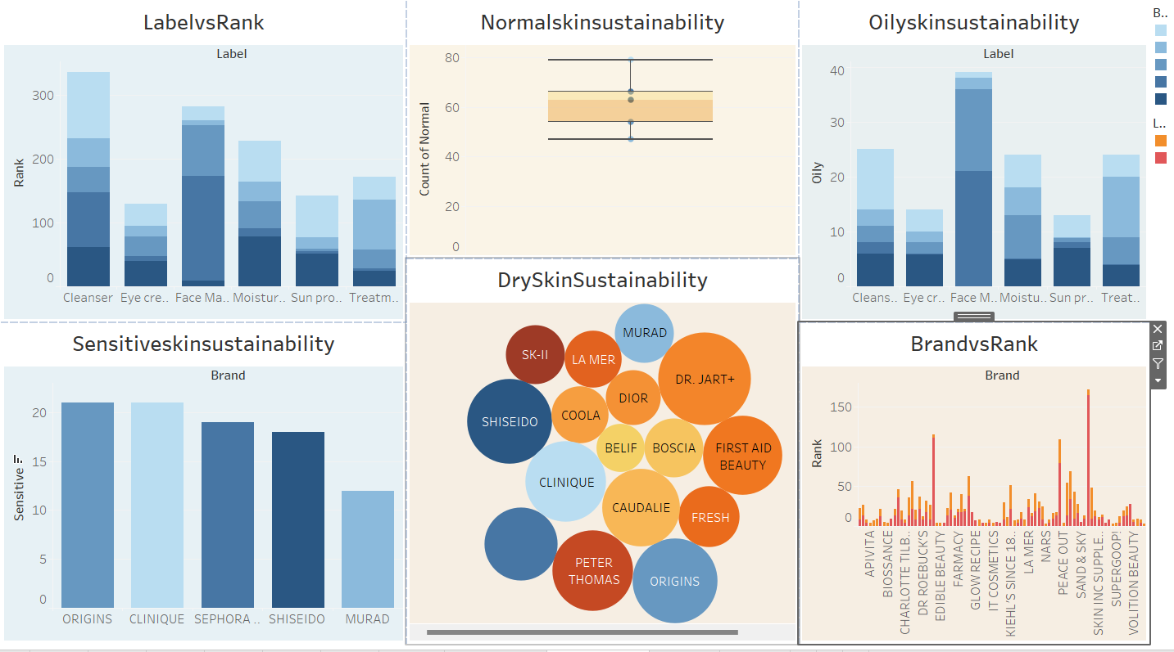

1. **Label Rankings (LabelvsRank):** The stacked bar chart shows that Cleansers have the highest ranking at around 350, followed by Face Masks at 300, indicating that these product categories are the most prominent in terms of label ranking, while Sun Protect ranks the lowest at around 50.
2. **Normal Skin Sustainability (Normalskinsustainability):** The box plot reveals that normal skin sustainability scores range from approximately 50 to 80, with a median around 65, suggesting a consistent performance across products for normal skin, with a few outliers scoring above 80.
3. **Oily Skin Sustainability (Oilyskinsustainability):** The stacked bar chart indicates that Face Masks lead in oily skin sustainability with a count of around 40, followed by Cleansers at 25, showing that these categories are most associated with addressing oily skin concerns, while Sun Protect has the lowest count at 10.
4. **Dry Skin Sustainability (DrySkinsustainability):** The bubble chart highlights that brands like Dr. Jart+, First Aid Beauty, and Fresh have larger bubbles, indicating a stronger association with dry skin sustainability, while brands like Belif and Boscia have smaller bubbles, suggesting a weaker association.
5. **Sensitive Skin Sustainability (Sensitiveskinsustainability):** The histogram shows that Origins and Clinique lead with the highest scores for sensitive skin sustainability at around 21, followed by Sephora Collection and Shiseido at 19, while Murad scores the lowest at around 12, indicating varying suitability for sensitive skin across brands.